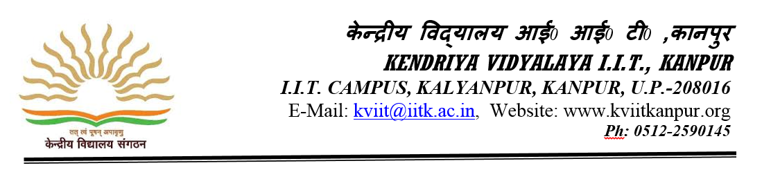

SWAYAM PRABHA DTH-TV CHANNEL#31 run by NCERT for School and Teacher education 2019
As a part of implementation of “Digital India Campaign” NCERT runs a DTH –TV Channel#31 named as “Kishore Manch” for Secondary and Senior Secondary School Students, teachers and teachers educators. Every Day a new content will be uploaded of 6 hours which will be repeated thrice a day. Students can choose their convenient time to watch video contents. Please use the following settings in the set-top box-
Downlink frequency: -11670 MHz; Polarization- Vertical; LNB Frequency – 9750; Symbol Rate- “29500 Ksps FEC”
After settings, viewers can watch the telecast of “Kishore Manch”channel on DD Free Dish(Channel No.128) and Dish TC(channel No. 2370) along with Jio TV Mobile App.
Monthly telecast schedule is also available on ciet.nic.in or ncert.nic.in and can be downloaded. It also live sessions on Teacher education, Art & Craft, Vocational Education, Guidance & Counselling, ICT in Education & research etc. These programs can be viewed from 04:00pm to 04:30pm on working days.
Through these live programs, the students , teachers and teachers educators may interact with the experts through toll free no. 1800 11265 & 1800 112199 and also on email id- ciet.kishoremanch@gmail.com. They may also connect through social media platforms of NCERT and CIET i.e. Youtube(NCERT Official), Facebook(@ncertofficial) and Twitter CIET(@ciet_ncert) or NCERT(@ncert) and ePathshala “Kishore Manch” Mobile app.

Principal
KV IIT Kanpur

