A. POST GRADUATE TEACHERS

ESSENTIAL QUALIFICATIONS:
- Two years integrated Post Graduate M.Sc. Course of Regional Institute of Education of NCERT in the concerned subject; OR
Master's Degree from a recognized University with at least 50% marks in aggregate in the following subjects: -

S.N. | Name of Post/ Subject | Subject (s)
1. | PGT (English) | English
2. | PGT (Hindi) | Hindi or Sanskrit with Hindi as one of the subjects at Graduate level
3. | PGT (Physics) | Physics/ Electronics/ Applied Physics/ Nuclear Physics
4. | PGT (Chemistry) | Chemistry/ Bio. Chemistry
5. | PGT (Economics) | Economics/ Applied Economics/ Business Economics
6. | PGT (Commerce) | Master’s degree in Commerce. However, holder of Degree of  M.Com in Applied/ Business Economics shall not be eligible.
7. | PGT (Math.) | Mathematics/ Applied Mathematics
8. | PGT (Biology) | Botany/ Zoology / Life Sciences/ Bio Sciences/ Genetics/ Micro Biology/ Bio-Technology/ Molecular Biology/ Plant Physiology  provided they have studied Botany and Zoology at Graduation level
9. | PGT (History) | History
10. | PGT (Geography) | Geography

- B.Ed. or equivalent degree from a recognized University.

- Proficiency in teaching through Hindi and English medium.

Note: Candidates having Special B.Ed. are not eligible for the post of PGT. Desirable Qualification: Knowledge of Computer Applications.

B. POST GRADUATE TEACHERS (COMPUTER SCIENCE)

ESSENTIAL QUALIFICATIONS:
i.
S.No. | Name of Post/ Subject | Qualification (s)
1. | PGT (Computer Science) | Essential:  1. At least 50% marks in aggregate in any of the following:  B.E or B.Tech (Computer Science/ IT) from a recognized University or an equivalent Degree or Diploma from an institution/ university recognized by the Govt. of India. OR
 |  | B.E or B.Tech (any stream) and Post Graduate Diploma in Computers from any recognized University OR
 |  | M.Sc. (Computer Science)/ MCA or Equivalent from a recognized University. OR
B.Sc. (Computer Science)/ BCA or Equivalent and Post
Graduate degree in any subject from a recognized University. OR
Post Graduate Diploma in Computer and Post Graduate degree
in any subject from a recognized University. OR
 |  | ‘B’ Level from DOEACC and Post Graduate degree in any subject. OR
 |  | ‘C’ Level from ‘DOEACC’ Ministry of Information and Communication Technology.
ii. Proficiency in teaching in Hindi and English medium.
C. TRAINED GRADUATE TEACHERS

ESSENTIAL QUALIFICATIONS:

- Four Years Integrated Degree Course of Regional College of Education of NCERT in the concerned subject with at least 50% marks in aggregate; or
Bachelor's Degree with at least 50% marks in the concerned subject/ combination of subject and in aggregate. The elective subjects and languages in the combination of subjects as under:
S.No. | Name of Post/ Subject | Subject(s)
1. | TGT (English) | English as a subject in all the three years.
2. | TGT (Hindi) | Hindi as a subject in all the three years.
3. | TGT (S. St.) | Any two of the following: -  History, Geography, Economics and Pol. Science of which one must be either History or Geography
4. | TGT (Science) | Botany, Zoology and Chemistry.
5. | TGT (Sanskrit) | Sanskrit as a subject in all the three years.
6. | TGT (Maths) | Bachelor Degree in Maths with any two of the following subjects: -  Physics/ Chemistry/ Electronics/ Computer Science/ Statistics
7. | TGT (Assamese) | Assamese as a subject in all the three years.

- B.Ed. or equivalent degree from a recognized University.
- Central Teacher Eligibility Test (CTET) conducted by the CBSE

- Proficiency in teaching in Hindi and English medium.
Desirable: Knowledge of Computer Applications.

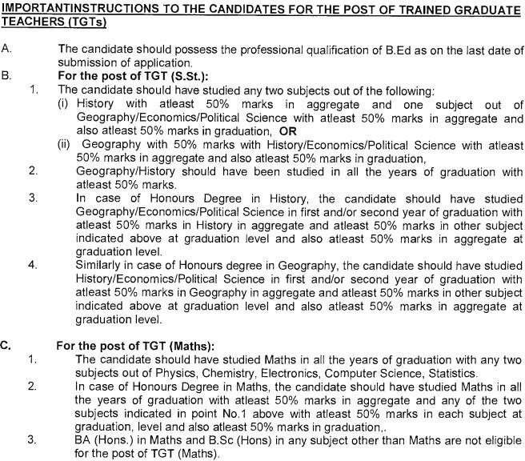

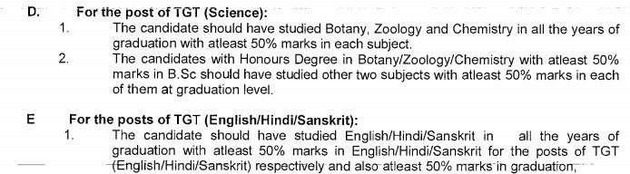

ESSENTIAL QUALIFICATION FOR PRIMARY TEACHER

Name of post | Qualification(s)
Primary Teacher | Essential:  - Senior Secondary (or its equivalent) with at least 50% marks and 2- year Diploma with Elementary Education (by whatever name known)  OR  Senior Secondary (or its equivalent) with at least 50% marks and 04 year Bachelor of Elementary Education (B. El. Ed)  OR  Senior Secondary (or its equivalent) with at least 50% marks and 02-year Diploma in Education (Special Education)  - Qualified in the Central Teacher Eligibility Test (Paper-I) conducted by the Govt. of India  - Proficiency to teach through Hindi and English medium.  Desirable:  Knowledge of working on Computer.
Balvatika Teacher | Qualification for Balvatika Teachers shall be as prescribed by NCTE.  - Senior Secondary class (Class XII or its equivalent from a recognized board with at least 50% marks.  &  - Diploma in Nursery Teacher Education/Pre-school Education/Early childhood Education Programme (D.E.C.Ed) of duration of not less than two years or B.Ed.(Nursery) from NCTE recognized Institution.

E. MISCELLANEOUS : ESSENTIAL QUALIFICATIONS
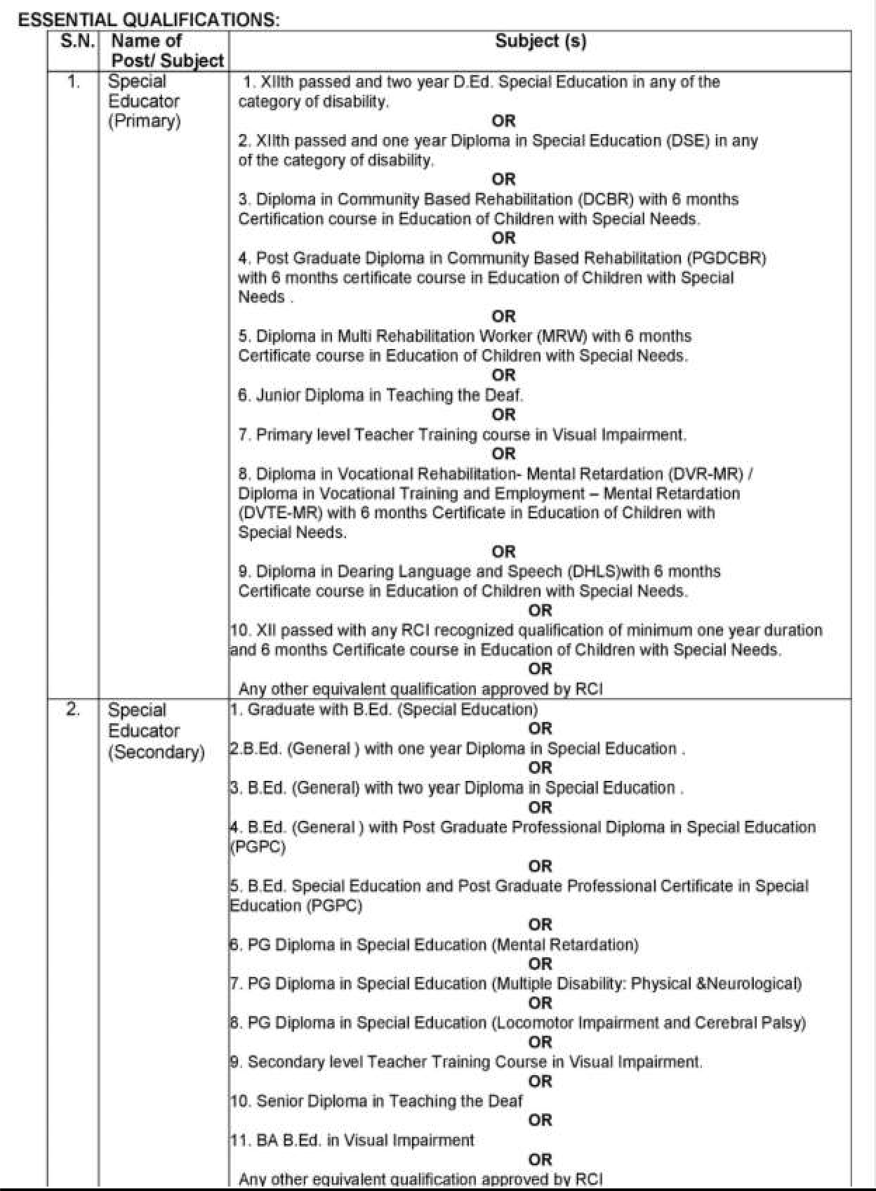

2 | Computer Instructor | 1. At least 50% marks in aggregate in any of the following:  B.E or B.Tech.(Computer Science/ IT) from a recognized Universityand Post Graduate Diploma in Computers from recognized University.  OR  M.Sc(Computer Science)/ MCA or Equivalent from a recognizedUniversity.  OR  B.Sc (Computer Science) / BCA or Equivalent and Post Graduatedegree in subject from a recognized University.  OR  Post Graduate Diploma in Computer and Post Graduate degree in anysubject from recognized University.  OR  ‘B’ Level from DOEACC and Post Graduate degree in any subject.  OR  ‘C’ Level from ‘DOEACC’ Ministry of Information and Communication Technology and Graduation.  2. Proficiency in teaching in Hindi and English.
3 | Coaches in Games and sports | Diploma/Degree/Graduation in concerned field, Specialization if any Represented in any at State/National level (If applicable) Proficiency in English and Hindi.  Knowledge of computer/ICT
4 | Coaches in Music & Dance/ Art &  Craft | Diploma/Degree/Graduation in concerned field Specialization if any Represented in any at State/National level (If applicable) Proficiency inEnglish and Hindi.  Knowledge of computer/ICT
5 | Yoga | Graduation in any subject or equivalent from recognized university and one year training in Yoga from recognized institutions.
6 | Nurse | Diploma in General Nursing and Midwifery with registration in the  Nursing Council
7 | Academic counsellor | Essential: BA/BSc (Psychology) from a recognized college or university  + regular one year post graduate diploma in guidance and counselling with at least 50% marks. Desirable: Minimum one year experience in providing career/educational counselling to students as schools Or working knowledge and experience in placements bureau Or Registration with rehabilitation counselling of India as vocational  counsellor.
8 | Doctor | MBBS & Registered with MCI
NOTE- SPECIAL INSTRUCTIONS TO THE CANDIDATES

  - Qualifications acquired by the candidates should be strictly in accordance with the prescribed qualifications and candidate should not seek claim of equivalence of their qualifications with that of qualifications as asked for. Wherein grades have been given, equivalence marks of gradation should be attached.
  - The Candidate should not fill in those qualifications in the application form for which they have appeared in any of the examination whose result is awaited/ withheld/ not declared.
  - A candidate must apply separately for different posts.
  - Canvassing in any form will disqualify a candidate.
  - No TA/DA will be paid for appearing in the walk-in- interview

